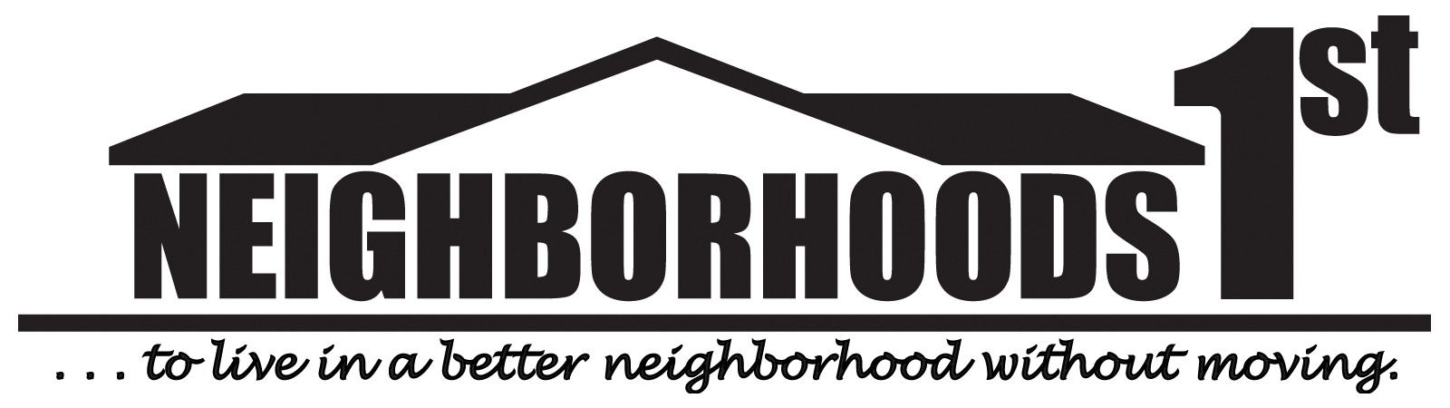
City of Hagerstown Neighborhoods 1st Program
Budget Proposal

Neighborhoods 1st Group: ________________________________________________________

Event: _______________________________ Expected Attendance: _____________________

Brief Description of event: _______________________________________________________

______________________________________________________________________________
______________________________________________________________________________

Date: _________________________________ Rain Date: _____________________________

Contact: _______________________________ Phone: _________________________________

Email: ________________________________ Date Submitted: _________________________

Item | Unit Cost | Quantity | Total
Grand Total

Please submit an estimate for anticipated costs 6 -8 weeks prior to the event.
Categories of expenditures are acceptable and detailed breakdown is not necessary.

Submit to Cindy Blackstock: cblackstock@hagerstownmd.org or
City Hall, 1 E. Franklin St., Room 401, Hagerstown, MD 21740

